Quantified Student

Analyse Microservice

Created by G. Malisz

Content

1. Version History 2

2. Overview 2

3. Design 2

3.1. Domain-Driven Design 2

3.2. Level 3 of C4 model 3

3.3. UML 4

4. Weather Data 4

5. Data Source Change 5

6. Conclusion 5

# Version History

|  |  |  |  |
| --- | --- | --- | --- |
| Version | Date | Author | Comment |
| 0.1 | 02.06.2023 | G. Malisz | Structure, Overview, Design, Data Analysis, Optimisation, Conclusion. |

# Overview

The Analyse Microservice serves as the central point of the Quantified Student System, responsible for gathering data from other microservices, analysing, correlating, and processing it for presentation within the Dashboard Graphs. This microservice acts as a data aggregator, collecting information from various sources such as the Weather Data Microservice, Canvas Data Microservice and other relevant components. The Analyse Microservice extracts valuable insights from the collected data. It is used to identify correlations, trends, and patterns, allowing students to gain a deeper understanding of the factors influencing their performance. The processed data is then transformed into data packs, which are seamlessly integrated into the student performance dashboard.

# Design

## Domain-Driven Design

The Analyse Microservice was developed using Domain-Driven Design (DDD) principles, which played a crucial role in simplifying and structuring the development process. By adopting DDD, the microservice was designed with a clear focus on its core domain and responsibilities within the Quantified Student System. This approach helped to break down complex functionalities into manageable and cohesive domains, resulting in a more organized and maintainable codebase. Another benefit of employing DDD in the development of the Analyse Microservice is that it promotes a shared understanding and consistent modelling across other microservices within the system. With other microservices also embracing the same design approach, models can be shared between them, enabling easier communication and data exchange.

## Level 3 of C4 model

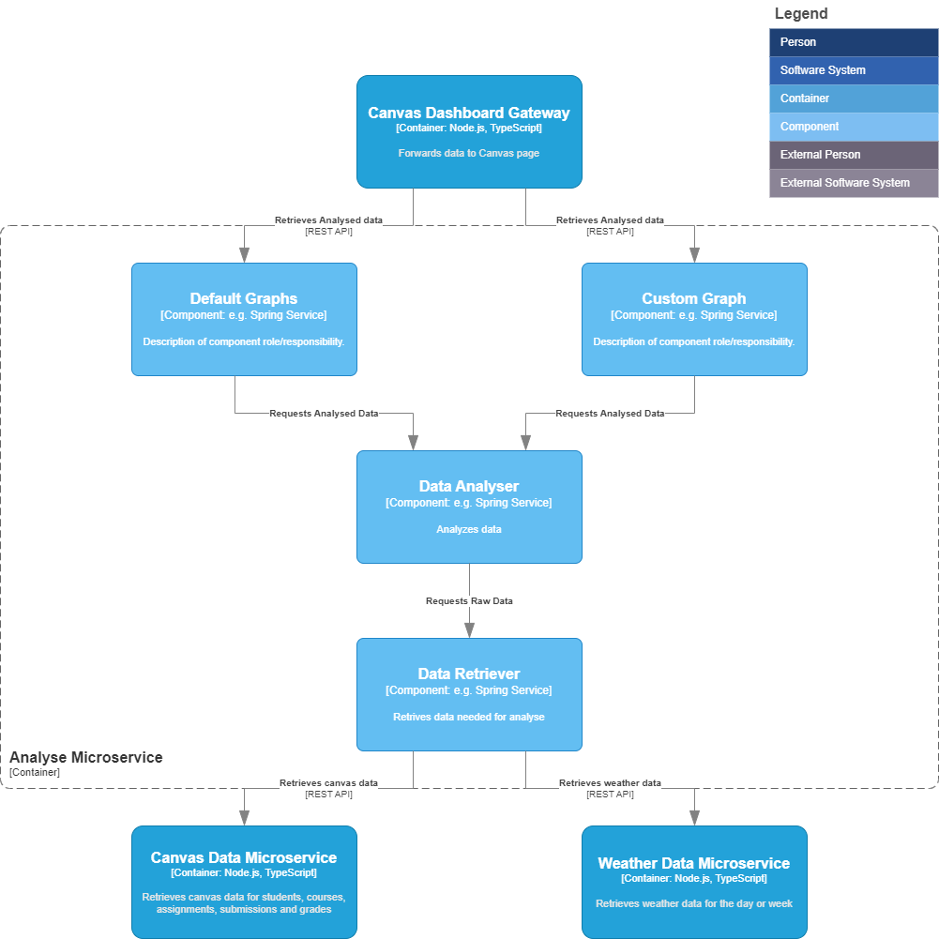

## UML

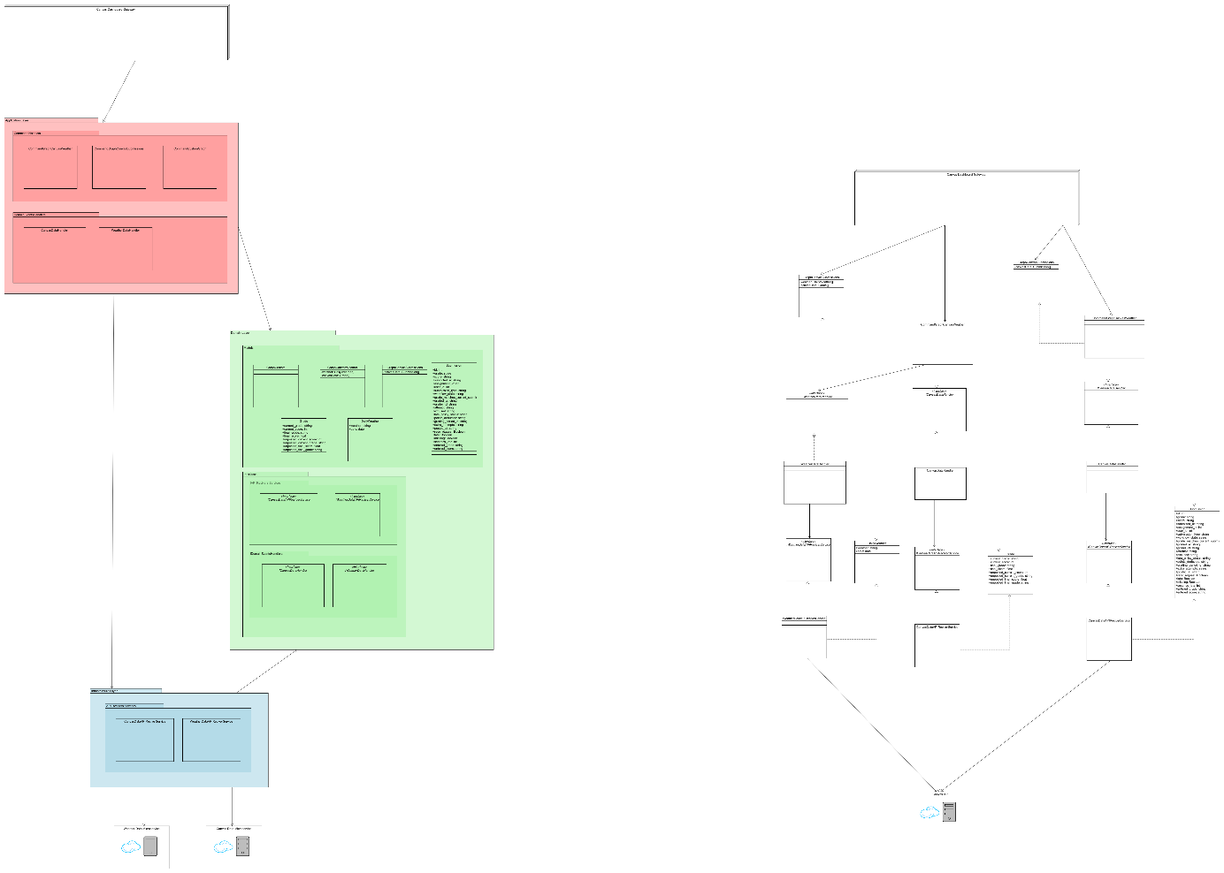

# Data Analysis

The Analyse Microservice correlates student performance with weather conditions and presents the amount of student submissions from courses within specified time frame.

In terms of weather data, the Analyse Microservice integrates relevant weather information to examine its potential impact on student performance. By analysing the relationship between weather patterns and student outcomes, stakeholders gain valuable insights into how external factors may influence academic achievements. This correlation allows for a deeper understanding of how weather conditions, such as temperature, day length or precipitation, may affect student performance trends.

In addition, the Analyse Microservice also considers the amount of student submissions within courses. By analysing submission patterns and their correlation with student performance, the microservice provides insights into the relationship between engagement and academic success. This enables stakeholders to identify trends and patterns related to student effort, participation, and submission consistency, ultimately contributing to a holistic understanding of student performance.

As part of future enhancements, the Analyse Microservice aims to empower students by providing them with the ability to choose their own data sources for comparison. This personalized approach will enable students to explore and analyse correlations between their performance, weather conditions, and submission patterns that are most relevant to their academic journey. By offering this flexibility, the microservice fosters student engagement and ownership of their academic progress, enhancing the overall student experience within the performance dashboard.

The Analyse Microservice introduces internal API endpoints that enable seamless access to data from other microservices within the Quantified Student System. This feature facilitates efficient data sharing and retrieval, ensuring easy access to the necessary information required for analysis and correlation. By providing a unified interface for data exchange, the Analyse Microservice enhances the overall integration and accessibility of critical data throughout the system, contributing to a more cohesive and efficient student performance analysis.

# Optimalisation

During the development of the Analyse Microservice, optimisation became a crucial aspect due to the prolonged data retrieval times. To improve performance, data objects were trimmed down to essential attributes, reducing the payload and enhancing response times. Additionally, new API endpoints were designed to bundle necessary data, reducing the number of API calls required. These optimisation measures significantly expedited data retrieval and improved the overall efficiency of the Analyse Microservice, resulting in a faster and more streamlined user experience within the student performance dashboard.

To address the existing 0.9 second delay in responses from the Canvas Server, further optimization of the Analyse Microservice might involve transitioning from a REST API to GraphQL. By adopting GraphQL, the Canvas Data Microservice might achieve more efficient and targeted data retrieval, resulting in improved responsiveness and overall performance.

# Conclusion

In conclusion, the Analyse Microservice plays a pivotal role within the Quantified Student System, correlating student performance with external factors such as weather conditions and submission patterns. By analysing and processing data, the Analyse Microservice provides valuable insights into the influences on student performance. With optimisations in place, including data size reduction and efficient API endpoints, the microservice ensures faster data retrieval and enhances overall system performance. The Analyse Microservice proves to be an essential component that empowers stakeholders with valuable analysis and correlation capabilities, contributing to a comprehensive understanding of student performance within the student performance dashboard.